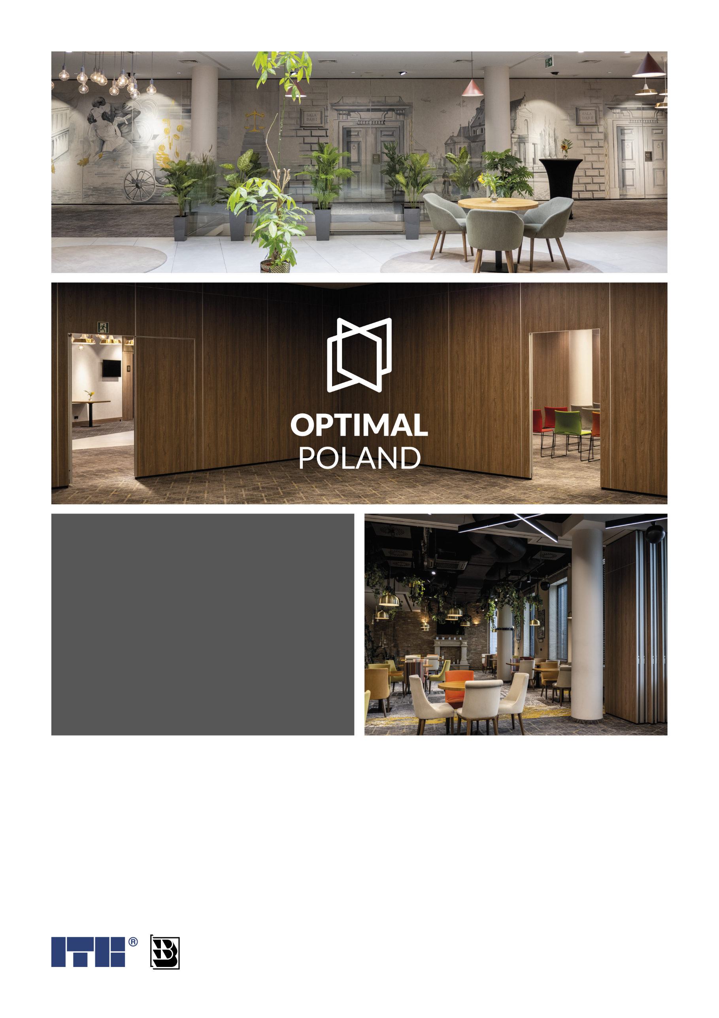
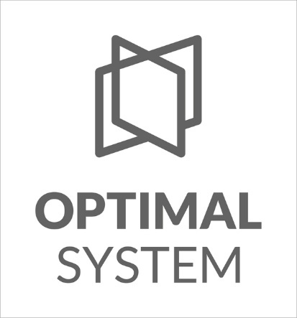

Creating
new
spaces

OFFER no 123-MM-26 dated: 02.02.2026 r.

Offer prepared by:

Michał Magala (+48 690 371 355 e-mail: m.magala@optimalpoland.com.pl)

All systems tested and certified by ITB, BRI Institute
Project Developer | Facility:
Podaj nazwę Inwestora. | Podaj miejsce realizacji.

Project Quotation:
W1:
System: | Optimal 110 | Cena ściany EUR
Dimensions: | L = Podaj długość mm
 | H = Podaj wysokość mm
Parking / Suspension type: | -
Sugested number of modules:
Acoustic value (Certified by BRI): | Rw = 45 dB
Covered with: | Melamine faced chipboard M3 class (D - s2,d0)
Operation: | -
Rail: | -
Doors: | -
Glass Modules: | -
Profiles: | -
Additional Equipment: | -
Additional notes:
+ Cena EUR

Transport rates:
Transport cost (miejscowość) : Modules (Stage 2) | Cena transportu EUR

Grand total:
Total value (walls & transport): | Wartość całej oferty EUR

Offer valid for 60 days only.

Offer includes:

- Technical advice
- Mobile wall design.
- Transport to the installation site (kerbside only)
- Production and supply of rails, and parking system (Stage I).
- Production and supply of movable wall modules (Stage II).
- 5-year product warranty of the direct Polish manufacturer.

Other applications:
- Connecting modules using a tongue and groove system with the use of magnetic and pressure seals. External distance between modules from 1 mm to 3 mm.
- Horizontal clamping bars in black.
- The use of a door module reduces the level of sound insulation by 2dB.
- In the case of walls higher than 2.80 m, it is necessary to join cladding boards. Panels up to a height of 5.60 m can be used in M1 class only.
- Availability of the full range of melamine manufacturers: Egger, SwissKrono, Finsa, Kronospan
- If cladding panels are used in the non-flammable class, Optimal 110 sliding walls meet the NRO (Non-Fire Propagation, class B-s1, d0 for 45 dB, class B-s2, d0 for others) requirement, in accordance with the National Technical Assessment ITB-KOT-2022/1699 issued by the Building Research Institute.
- The offer includes decors from the basic colour palette of Optimal System

This offer is intended only for the person or entity to whom it is addressed and contains content covered by trade secrets and trade secrets within the meaning of the Act on Combating Unfair Competition, as well as other content of a confidential nature. The Offerer does not agree to the dissemination of its content, but the terms and conditions of the offer are not publicly available, because the Offerer has taken steps to prevent the public from making the prices and other commercial terms and conditions available to the public.
Acceptance of this offer is tantamount to acceptance of the General Terms and Conditions of Sale of Optimal System Sławomir Więsyk available on the website: www.optimalpoland.pl

